 Patient Newsletter Summer 2023

**Demand in General Practice**

We are aware that nationally the demand in General Practice is extremely high and we are working extremely hard to meet this demand. If we have met capacity our reception team will direct you to next appropriate service, this may be a Community Pharmacy, Walk in Centre or 111.

Our Reception Staff are highly trained, and information is taken confidentially in the back-office area. Their training is extensive and has been developed by our GP Partners to allow them to effectively facilitate you seeing the most appropriate person or service. This has been viewed by several patients as being asking inappropriate questions or being 'nosey'. This is not the case; the questions allow the reception team to prioritise and highlight any urgent symptoms that need to be directed to urgent care.

Please be kind to our Reception Team, they work extremely hard to support our patients and do so in the appropriate way they have been trained to do.

**Additional Roles in General Practice**

It may not be a GP that you need to see for your symptoms, please help us to use GP time for patients who require it. Reception staff will arrange an appointment if a more appropriate clinician can help. We have several clinical and non-clinical staff who can help

**Clinical Pharmacists**

**Anju Mahajan, Maryam Rehman, Humarah Farooq & Bin Kumar.**

A clinical pharmacist is the person to see for expert advice around medicines. If you are experiencing side effects from your medicines, your clinical pharmacist will work with you to find a solution. If you are taking several different medicines, the clinical pharmacist can help make sure they are working well together.

Clinical Pharmacists can manage chronic diseases and support patients with the medication for these conditions.

**First Contact Physiotherapist**

**Ruth Humphry**

Physiotherapists help ensure you get the right care for your needs as quickly as possible. Physiotherapists provide patients with expert diagnosis and treatment for musculoskeletal conditions and can prevent the need for referral to hospital. Some physiotherapists can manage complex conditions, arrange tests such as scans, diagnose problems, and work out a management and treatment plan such as joint injections that would previously have been organised by a GP by way of a referral, which would encounter a wait to be seen.

**Advanced Clinical Practitioners (ACPs)**

**Khaled Ghrayeb-Grabe**

ACPs work alongside GPs and other practice staff to provide care to both adults and children. They can prescribe medication, order tests, interpret results, diagnose your health problems, and organise and create an appropriate treatment plan.

**Pharmacy Technician**

**Sophie Robins (Apprentice)**

Pharmacy technicians may be part of your practice team and undertake a range of tasks from preparing repeat prescriptions to helping you get the best outcomes from taking your medicines. Patients can often get the right advice from pharmacy technicians more quickly than if they waited for a doctor's appointment.

**Nurse Associates**

**Sue Hind (Trainee) & Carrie Ferneyhough (Trainee)**

Nursing associates help ensure you get the right care for your needs as quickly as possible. They bridge the gap between healthcare support workers and registered nurses to deliver hands-on, person-centred care as part of the nursing team. Nursing associates work with people of all ages who need help or advice but don't need to see a doctor or a nurse.

**General Practice Nurse (GPNs)**

**Claudine Winning & Mihaela Vaduva**

GPNs are undertaking an ever-wider range of roles. GPNs provide care and treatment for people from birth to end of life. They will look after patients with long-term diseases such as asthma and diabetes, offer health screening, as well as holding specialised clinics such as travel immunisations, baby immunisations, and women’s health for smear tests and contraception advice.

**Social Prescriber**

**Naoise Jephson**

Social prescribing link workers specialise in referring people to services outside the NHS which offer the opportunity for health, wellbeing, and practical and emotional support. In a general practice setting a social prescriber can take the time to talk about what matters to you and support you to find suitable activities that are a better alternative to medication. They connect people to community groups and services for practical and emotional support.

**Health and Wellbeing Coach**

**Derby County Community Trust**

A Health and Wellbeing Coach will coach and motivate patients through multiple sessions to identify their needs, set goals, and support patients to achieve their personalised health and care plan objectives. Where required, they can refer people back to other health professionals within the practice.  
You can get support from a health and wellbeing coach at your GP practice so ask your practice next time you get in touch for more information or patients can self-refer here: [www.derbycountycommunitytrust.com](http://www.derbycountycommunitytrust.com)

**Keep us up to date…**

We need your consent to send SMS messages, let reception know you are happy to receive emails and/or text messages.

Please update us if you change any of your contact details to ensure your records are up to date.

**Patient Participation Group (PPG)**

We are seeking patients to join our Patient Participation Group (PPG).

What are the benefits of a patient participation group?

* Patients will have a better understanding of how the surgery works
* There will be improved communication between patients and staff
* Patients will have a forum to suggest ideas and raise concerns
* Patients will be consulted about arrangements in the GP surgery before decisions are made
* Patients’ views will be represented in local health care
* Ideas of a wide range of people will be represented

The group meets every 2 months on a Wednesday morning. If you are interested in joining Village Surgery PPG, please leave your name and contact details with the Reception Team or email [villagesurgery.reception@nhs.net](mailto:villagesurgery.reception@nhs.net)

**Closed Dates**

Staff training

* Wednesday 21st June from 1.30pm
* Wednesday 19th July from 1.30pm
* Wednesday 20th September from 1.30pm

During these times 111 or the walk-in centre are available for urgent medical attention. Or call 999 for life-threatening emergencies.

**We are on Facebook!! @VillageSurgeryDerby**

**Please follow us for regular updates and Surgery news**

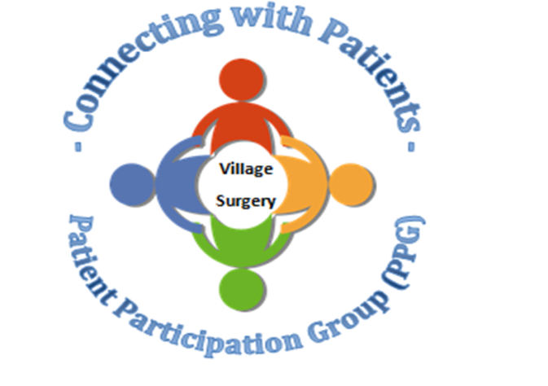

Relias training

There is still a lot of online training outstanding. Please complete as soon as possible.

<https://villagesurgeryderby.training.relias.co.uk>

[If you are unsure of your log on details let Claire or Lauren know.](https://villagesurgeryderby.training.relias.co.uk)

Autumn 2019

Autumn 2019

Upcoming Quest Sessions

• 20th November 2019—we are hoping to do a ‘scenario’ afternoon. As emergency situations are an ‘emergency’ we don’t get to practice before they happen. This will be an opportunity for staff to practice these emergency situations and also to highlight areas that need attention.

• 18th December 2019—Christmas fuddle. We will be having a fun Christmas afternoon, exchanging secret Santa gifts, eating food and playing games.