 Patient Newsletter Summer 2022

**Covid – 19**

The directive from NHSe is that GP practices have returned to normal service, whilst this is true on the surface, we are still required to maintain most precautions that have been set since March 2020 to ensure patient and staff safety.

Since the beginning of the pandemic, we have been supported by the 'Red Hub' which allowed practices over the city to reduce the number of respiratory/suspected covid patients entering practices, however this closed at the end of June, which has meant the risk of exposure to covid-19 in practices has increased.

We ask that patients who suspect or have confirmed they have covid highlight this at the time of contact with the practice to ensure vulnerable patients and staff members can be protected. Covid positive patients will still receive the care a treatment that they require, and no patients will be turned away, but it gives the practice the opportunity to protect any vulnerable patients sat in the waiting room and allows staff to prepare in full PPE.

Staff will continue wearing face masks and we ask that patients also wear one, this is to protect vulnerable patients and staff. There has been an increase in covid positive NHS employees across the country which has a huge impact on NHS services, please keep our staff safe to ensure we can continue to offer a fully working practice!

We thank you for your continued support! If you have any queries or concerns, do please contact the Practice we are happy to discuss these with you.

**#ChooseWell**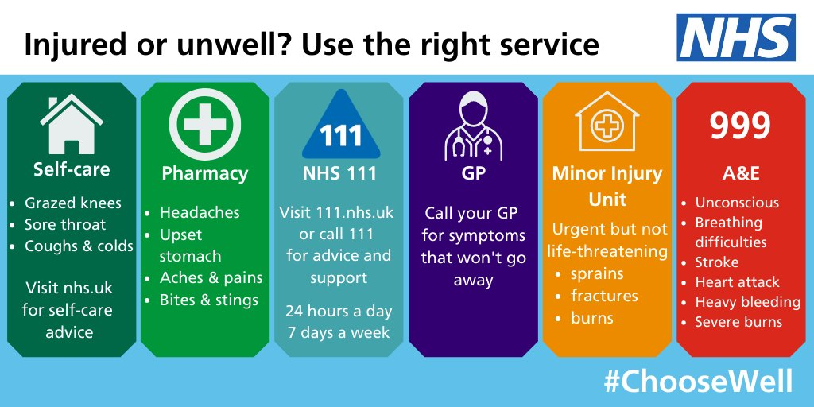

**Keep us up to date…**

We send regular communications by SMS as well as direct links to book appointments through.

Due to the Data Protection Regulations changing in May 2018 our process for sending SMS messages and emails changed. If you are happy to receive emails and/or text messages please advise our Reception Team so that your consent can be added to your medical record.

Please update us if you change any of your contact details to ensure your records are up to date.

**Staff update**

**Retirement**

On 28th July 2022 Cathy retired after 16 years working on reception, a lot of you will have met her along the way. She had a wonderful but emotional send off. We would like to wish Cathy a long and happy retirement; she will be missed by all!

**Flu Campaign 2022**

Flu cohorts:

* Over 65s
* at risk patients aged 0-64
* 50–64-year-olds 'not at risk'
* children aged 2-3

We have had a vaccine delivery date confirmed for the over 65 vaccines and are awaiting confirmation of delivery date for the under 65s.

Flu clinic dates (confirmed):

* Over 65s – 1st October
* Children aged 2-3 – 19th October

Plans for the under 65 cohorts will be shared once a delivery date is confirmed.

Patients will be contacted to book an appointment; this will include SMS messages with a direct link to book an appointment. Please ensure the practice has your consent to receive SMS messages and an up-to-date telephone number.

**Patient Participation Group (PPG)**

We are seeking patients to join our Patient Participation Group (PPG).

What are the benefits of a patient participation group?

* Patients will have a better understanding of how the surgery works
* There will be improved communication between patients and staff
* Patients will have a forum to suggest ideas and raise concerns
* Patients will be consulted about arrangements in the GP surgery before decisions are made
* Patients’ views will be represented in local health care
* Ideas of a wide range of people will be represented

The group meets once a month on a Wednesday morning. If you are interested in joining Village Surgery PPG, please leave your name and contact details with the Reception Team.

**We are on Facebook!! @VillageSurgeryDerby**

**Please follow us for regular updates and Surgery news**

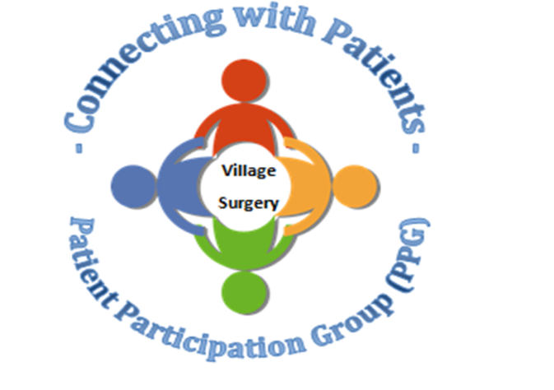

**Closed Dates:**

Staff training

* Wednesday 21st September from 1.30pm
* Wednesday 19th October from 1.30pm
* Wednesday 16th November from 1.30pm

Bank Holidays 2022

* Monday 29th August
* Monday 26th December
* Tuesday 27th December

During these times 111 or the walk-in centre are available for urgent medical attention. Or call 999 for life-threatening emergencies.

Relias training

There is still a lot of online training outstanding. Please complete as soon as possible.

<https://villagesurgeryderby.training.relias.co.uk>

[If you are unsure of your log on details let Claire or Lauren know.](https://villagesurgeryderby.training.relias.co.uk)

Autumn 2019

Autumn 2019

Upcoming Quest Sessions

• 20th November 2019—we are hoping to do a ‘scenario’ afternoon. As emergency situations are an ‘emergency’ we don’t get to practice before they happen. This will be an opportunity for staff to practice these emergency situations and also to highlight areas that need attention.

• 18th December 2019—Christmas fuddle. We will be having a fun Christmas afternoon, exchanging secret Santa gifts, eating food and playing games.