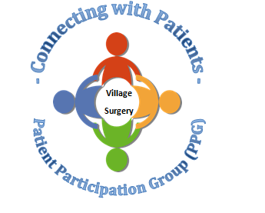

Do you want to: -
- Assist your Practice to benefit patients?
- Help the surgery adapt and develop services?
- Have a say in what happens locally?
Meetings will be held over Microsoft Teams to remain Covid safe.
If you are interested in joining the group, please email villagesurgery.reception@nhs.net for the attention of the Management Team.
Closing date for applications: 6th February 2022

