 Patient Newsletter Summer 2020

**Covid – 19**

During the last 4 months the Practice has had to radically change the way in which we see and consult with patients. These changes have been implemented to keep our patients and our staff as safe as possible.

At the end of March we moved very swiftly to a total triage model, cancelling a lot of face-to-face appointments and replacing them with the telephone consultations as well as video consultations. Our Nursing team has also adapted well and although we have continued to see patients face-to-face, a lot of the long term condition reviews have been conducted over the telephone and patients have even had video consultations and education on how to manage their dressings.

The Government have eased rules and lockdown arrangements but as I expect most of you will appreciate we are still in a very worrying time of managing the risks of what easing these restrictions could mean to our communities.

NHS England has published a standard operation procedure which Primary Care must comply with. A vital part of this procedure is to minimise footfall through the practice and to operate a “remote management” appointment system. This means for us and for our patients that prior to being seen by a Clinician you will be assessed in remote style, this could be via submitting an eConsult or by booking a telephone appointment. If the Clinician, after speaking to you, decides they would like to see you, they will either arrange a video consultation or ask you to come to an appointment.

We are now being asked by NHS England and the Government to increase activity at the Practice; invitations for cervical screening are returning to normal recall, and we’re being encouraged to do as much as we can in the way of routine work now to avoid a big backlog when we hit flu season.

We therefore are encouraging patients to attend the Practice and blood venues for their routine blood tests and health checks, if they receive invitation to do so. We can reassure you that we’re cleaning all surfaces and equipment between patient consultations and regularly throughout the day, wearing appropriate PPE and taking all precautions so that we can to protect both patients and staff. We understand that some patients will be reluctant to come to the practice but the number of patients being seen remains quite low. At present (and weather permitting) we’re not allowing patients to wait in the waiting room as the number outside is manageable.

We are however asking patients to wear a face covering when they attend the Practice. We have installed screening around our reception desk as well, as a further level of protection between our staff and patients.

The team here are doing everything they can to keep us all safe. Every decision made is in the best interest of our patients, staff and our community.

This has been a very challenging time for all of us and we are so proud of our team here who have continued to work through every day of this pandemic. We would like to ask you all to respect this and hold onto this thought. Some Practices have had to close, some have had to centralise some of their services, but we have done everything in our power to continue to run and deliver a local service by staff that you know. Whilst we appreciate the frustration and worry that this horrible situation brings (to us all) please remember, our staff are doing their best for you and unpleasant or abusive behaviour towards them will not be tolerated.

We would like to thank all our patients for being accommodating and accepting of all the changes we have had to rapidly implement.

If you have any queries or concerns, do please contact the Practice we are happy to discuss these with you.

**New GPs**

We are excited to welcome to our team Dr R Ibrahim. She will be starting work at the Practice as a Salaried GP on Wednesday 5th August 2020. She will be working 6 sessions over 4 days.

We also have a full time GP Registrar starting on Wednesday 5th August; Dr B Selvadurai will be working with us for 12 months. Some patients may recognize her as she did a 3 month placement with us in 2018/19. We are excited to welcome her back to our team!

**Flu Campaign 2020**

The patient’s eligible for the free flu vaccination is slightly different this year due to Covid-19 and the need to reduce the risk of flu and Covid-19 co-circulating. You may have seen the announcement about the extension of those eligible for a free flu vaccine to include shielded patients, household members of shielded patients and 50-64 year old patients.

We are required to order our flu vaccinations around March time each year, as you can imagine we didn’t anticipate the flu vaccination requirements to change so drastically and we are awaiting guidance from NHS England on how to obtain further supplies of flu vaccinations.

We currently have provisional plans for our usual ‘flu cohort’ of patients, these plans have been challenging to put together due to the social distancing guidance, the plans need to be robust in order to protect both patients and staff. These plans will be finalised shortly and shared with eligible patients accordingly.

**SMS & Email Messaging**

This is more important than ever due to Covid-19 and our new methods of consulting patients!

The changes in the Data Protection Regulations in May 2018 meant that our process for sending SMS messages and emails changed. If you are happy to receive emails and/or text messages please advise our Reception Team so that your consent can be added to your medical record.

We are sending regular updates via text message; please ensure all contact details are up to date.

**We are now on Facebook!! @VillageSurgeryDerby**

**Please follow us for regular updates and Surgery news**

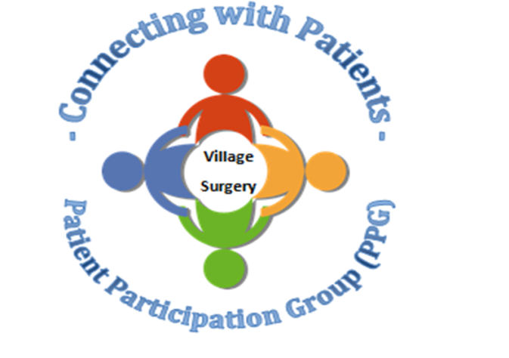

**Closed Dates:**

Whilst we have cancelled a number of our closed dates this year so far we will be continuing with the following dates:

Monday 31st August (Bank Holiday)

Wednesday 9th September from 1.30pm

Wednesday 14th October from 1.30pm

During these times 111 or the walk-in centre are available for urgent medical attention. Or call 999 if a life threatening emergency.

Relias training

There is still a lot of online training outstanding. Please complete as soon as possible.

<https://villagesurgeryderby.training.relias.co.uk>

[If you are unsure of your log on details let Claire or Lauren know.](https://villagesurgeryderby.training.relias.co.uk)

Autumn 2019

Autumn 2019

Upcoming Quest Sessions

• 20th November 2019—we are hoping to do a ‘scenario’ afternoon. As emergency situations are an ‘emergency’ we don’t get to practice before they happen. This will be an opportunity for staff to practice these emergency situations and also to highlight areas that need attention.

• 18th December 2019—Christmas fuddle. We will be having a fun Christmas afternoon, exchanging secret Santa gifts, eating food and playing games.