**AccuRx – Video Consult User guide for Patients**

**Step 1:** The GP will send you a Link to your mobile phone –

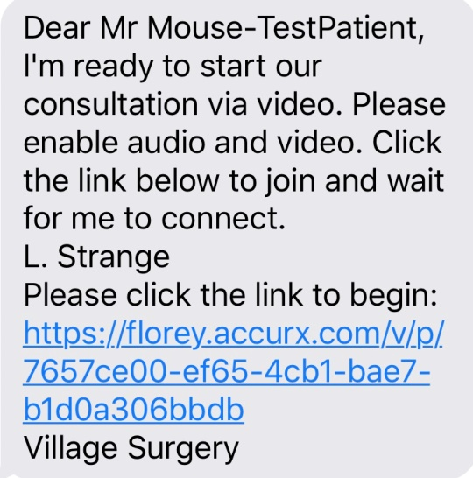

**Step 2:** Click on the link and follow the instructions.

**Step 3:** The link will open in your mobile phone browser. You will then be asked to test the microphone on the webcam, the Clinician will receive the same instructions on their phone/ Computer - Allow access to microphone –

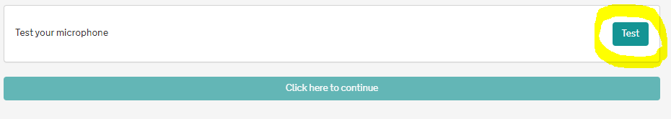

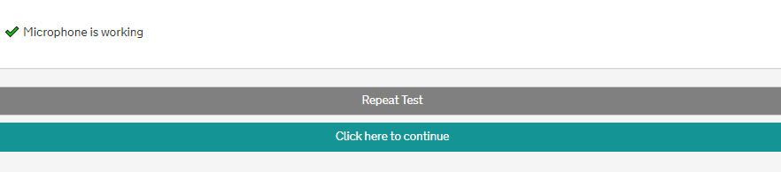

**Step 4:** You will then go through to a new screen that will ask for you to access the camera – Click on ‘Request Permissions’ and select allow when prompted, the clinician will have to complete these steps aswell.

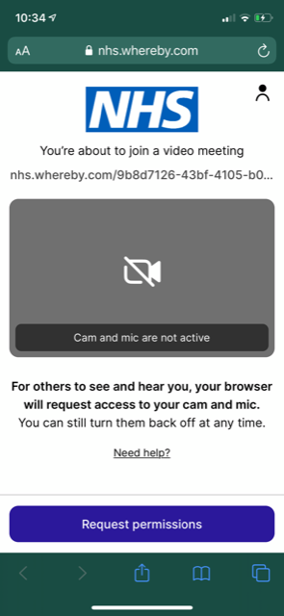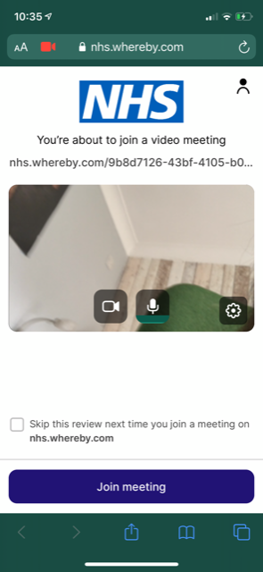

**Step 5:** When you are ready to leave the meeting press the little orange hand icon.