 Patient Newsletter Autumn 2019

**CQC – September 2019**

On 23rd September we had our CQC phone call.

The call was led by Verity Shelton (Practice Manager) and Dr Dew, supported by Lauren Strange and Claire Cooper (Asst. Practice Managers).

The phone call went really well and CQC have stated they have no concerns that our level of care has changed from good with outstanding features and confirmed they will not be visiting us.

We will receive a further phone call in 12 months’ time. CQC monitor all surgeries between visits and yearly phone calls, if they feel a visit is required the usual process of giving 2 weeks’ notice will be followed.

**Changes to Same Day Appointments**

From Monday 4th November 2019 the same day appointments booking system will be changing.

We will allow ALL same day appointments to be bookable from 8am.

Benefits:

• Easier access for patients - allowing afternoon appointments to be booked in the morning meaning no requirement to call back at 2pm

• Free up phone lines for patients to call in the afternoon during less busy periods for routine requests/test results, etc

• Planning of staff rotas to ensure the phone lines can have the maximum staffing during the busiest periods

We expect that this new process will run smoothly, as with all things ‘new’ we expect some teething problems, we will aim to overcome these as a matter of urgency.

#### **Charity Donations**

#### Donations made in the last 2 months:

#### Karma Nirvana—£50

#### Macmillan—£173

#### Dementia UK—£33.98

#### Breast Cancer—£40

Charity book sale—ongoing.

If you have a charity you would like the donations to go to please let our Reception Team know.

#### 

#### 

**SMS & Email Messaging**

The changes in the Data Protection Regulations in May 2018 meant that our process for sending SMS messages and emails changed.

If you are happy to receive emails and/or text messages please advise our Reception Team so that your consent can be added to your medical record.

Please ensure all contact details are up to date.

## Patient Participation Group (PPG)

Village Surgery is seeking patients to join our Patient Participation Group (PPG). We are looking for members from all sections of the community to attend quarterly meetings to discuss ideas for the Practice and its services to patients.

WHAT IS A PATIENT PARTICIPATION GROUP?

* Village Surgery PPG is made up of patients and practice staff who meet quarterly.
* The PPG discusses ways of making a positive contribution to the services and facilities offered to the patients.
* The group works to represent the views of the whole patient community.
* As a patient you can have a view on the things that matter in our health service.

WHAT IS THE PURPOSE OF A PATIENT PARTICIPATION GROUP?

* To give practice staff and patients the opportunity to discuss topics of interest in their practice.
* To provide the means for patients to make positive suggestions about the practice and their own health care.
* To act as a representative group which can be used to influence the local provision of Health and Social Care?

We held a recruitment meeting in October, which unfortunately only attracted 1 new member.

We will be meeting with them and the current 2 members quarterly but would like to expand the group further! If you would be interested in getting involved please leave your details with our Reception Team, either Verity Shelton (Practice Manager) or Claire Cooper (Asst. Practice Manager) will be in contact.

## Carers

We are looking to build our list of Carers, it is important that Carers get help and support to ensure they are able to carry on caring.

To keep going it is essential that carers look after their own health and well-being and that’s when Derbyshire Carers Association can help.

If you are a Carer please fill in our Carers form (available from reception). With your consent a referral to Derbyshire Carers Association can then be made.

If you would like more information our Reception Team will be happy to advise.

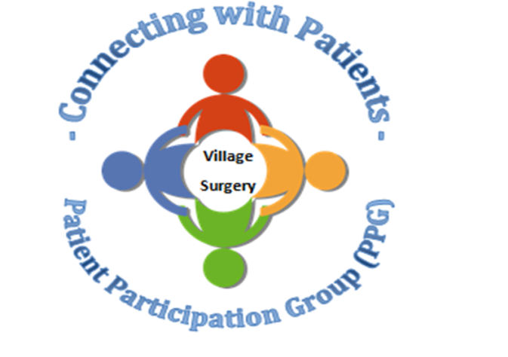

Closed Dates:

Wednesday 20th November from1.30pm

Wednesday 18th December from 1.30pm

Wednesday 25th December

Thursday 26th December

Wednesday 1st January

During these times 111 or the walk-in centre are available for urgent medical attention. Or call 999 if a life threatening emergency.

Relias training

There is still a lot of online training outstanding. Please complete as soon as possible.

<https://villagesurgeryderby.training.relias.co.uk>

[If you are unsure of your log on details let Claire or Lauren know.](https://villagesurgeryderby.training.relias.co.uk)

Autumn 2019

Autumn 2019

Upcoming Quest Sessions

• 20th November 2019—we are hoping to do a ‘scenario’ afternoon. As emergency situations are an ‘emergency’ we don’t get to practice before they happen. This will be an opportunity for staff to practice these emergency situations and also to highlight areas that need attention.

• 18th December 2019—Christmas fuddle. We will be having a fun Christmas afternoon, exchanging secret Santa gifts, eating food and playing games.